SQL PROJECT REPORT (MS WORD FORMAT)

Dairy Management System

1.INTRODUCTION
Content:
DAIRY MANAGEMENT SYSTEM USING SQL
A Database Management and Analysis Project
Submitted by: Ankita Chaturvedi
Course: Data science
Institution: IELEVATE INSTITUTE
Date:

2.Certificate Page

This is to certify that the project titled “Dairy Management System” is a bona fide work done by Ankita Chaturvedi...

Acknowledgement

I would like to express my gratitude to my teacher for guiding me throughout this SQL project.

3.INTRODUCTION TO PROJECT
The Dairy Management System is a structured database project developed using SQL to efficiently manage and analyze dairy farm operations. In traditional dairy management, data related to cattle, milk production, product inventory, sales, and revenue is often maintained manually, which can lead to errors, duplication, and difficulty in tracking overall performance.
This project aims to address these challenges by centralizing dairy-related information into a structured database for efficient storage, retrieval, and analysis. It includes essential details such as farm location, land area, number of cows, product details, production and expiration dates, stock availability, sales data, and revenue generation.
By using SQL queries, the system enables efficient data retrieval, analysis, and reporting. It helps in identifying key insights such as best-selling products, stock shortages, total revenue, and production trends. This makes decision-making easier and more data-driven for dairy farm management.
Overall, this project demonstrates how relational database concepts and SQL can be applied in real-world scenarios to improve accuracy, efficiency, and productivity in dairy operations.

4.OBJECTIVE
- Use action verbs consistently:
- To manage dairy farm and product data in a structured format.
- To store production, inventory, and sales information in a centralized database.
- To calculate revenue and stock availability using SQL queries.
- To analyze farm performance and product demand.
- To generate meaningful reports for decision-making.

5.DATABASE DESCRIPTION

Database Name: Dairy_Database

Table Name: Dairy

This database consists of a single table that contains all dairy-related operations.

Columns included:
- Location
- Total land
- Number of cows
- Farm size
- Order date
- Product ID
- Product name
- Brand
- Quantity
- Price per unit
- Total value
- Shelf life
- Storage condition
- Production date
- Expiration date
- Quantity sold
- Sales Price per unit
- Approx. total revenue
- Customer location
- Sales channel
- Quantity in stock
- Minimum stock threshold
- Reorder quantity

TABLE STRUCTURE
Column Name | Data Type
Location | VARCHAR
Total Land Area | DECIMAL
Number of cows | INT
Farm size | VARCHAR
Orders Date | DATE
Product ID | INT
Product Name | VARCHAR
Brand | VARCHAR
Quantity | DECIMAL
Price per unit | DECIMAL
Total Value | DECIMAL
Shelf Life | INT
Storage Condition | VARCHAR
Production Data | DATE
Expiration Date | DATE
Quantity Sold | INT
Sales price per unit | DECIMAL
Approx. Total Revenue | DECIMAL
Customer Location | VARCHAR
Sales Channel | VARCHAR
Quantity in Stock | INT
Minimum Stock Threshold | DECIMAL
Reorder Quantity | DECIMAL

6.Database Creation
Add screenshots of:
- CREATE DATABASE command
- USE database command
- CREATE TABLE command
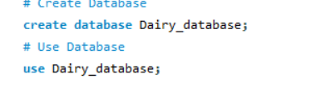

7. Business Questions & SQL Analysis
/*=========================================================
Business Question 1:
What is the total revenue generated by each dairy product?

Objective:
Calculate the total revenue generated by each product to
identify the highest-performing products and evaluate
their contribution to overall business revenue.
=========================================================*/
SELECT Product_Name,
SUM(Quantity * Price_per_Unit) AS Total_Revenue
FROM dairy
GROUP BY Product_Name;
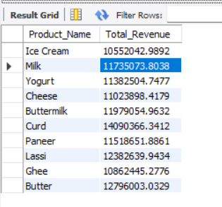
Business Insight
The analysis reveals that Ice cream generated the highest total revenue, indicating strong customer demand and significant contribution to overall business performance. This product should be prioritized for inventory management and promotional activities.

/*=========================================================
Business Question 2:
Which dairy brand generates the highest overall revenue?

Objective:
Identify the brand that contributes the highest revenue
to evaluate brand performance and support business
decision-making.
=========================================================*/
SELECT Brand,
SUM(Quantity * Price_per_Unit) AS Total_Revenue
FROM dairy
GROUP BY Brand
ORDER BY Total_Revenue DESC
LIMIT 1;
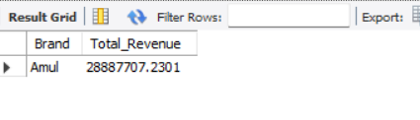
Business Insight
AMUL emerged as the highest revenue-generating brand, demonstrating its strong market presence and customer preference. Increasing the availability and marketing efforts for this brand could further improve revenue.

/*=========================================================
Business Question 3:
How does revenue vary across different months?

Objective:
Analyze monthly revenue trends to identify seasonal
patterns and evaluate overall business performance
throughout the year.
=========================================================*/
SELECT MONTH(Orders_Date) AS Month,
SUM(Quantity * Price_per_Unit) AS Total_Revenue
FROM dairy
GROUP BY MONTH(Orders_Date)
ORDER BY Month;
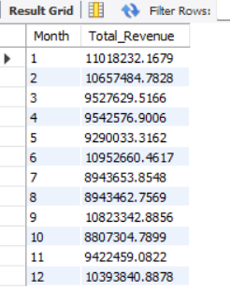
Business Insight
Revenue analysis shows noticeable variations across different months. The month of January recorded the highest revenue, indicating potential seasonal demand patterns that can support future sales planning.

/*=========================================================
Business Question 4:
Which products have inventory levels below the minimum
stock threshold?

Objective:
Identify products that require immediate attention for
inventory management and stock replenishment.
=========================================================*/
SELECT Product_Name,
Quantity
FROM dairy
WHERE Quantity < 5;
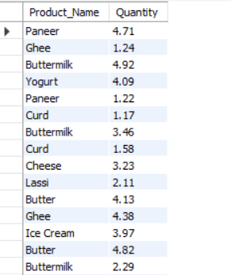
Business Insight
The identified low-stock products require immediate attention to prevent stock shortages and maintain product availability. Timely inventory replenishment can improve customer satisfaction and reduce lost sales.

/*=========================================================
Business Question 5:
How many units should be reordered for products with
low inventory?

Objective:
Calculate the required reorder quantity for low-stock
products to maintain adequate inventory levels.
=========================================================*/
SELECT
Product_Name,
Quantity AS Current_Stock,
(20 - Quantity) AS Reorder_Quantity
FROM
dairy
WHERE
Quantity < 5;

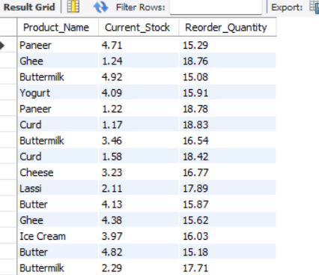
Business Insight
The calculated reorder quantities provide a clear inventory replenishment plan, helping maintain optimal stock levels while reducing the risk of overstocking or stockouts.

/*=========================================================
Business Question 6:
Which sales channel generates the highest total revenue?

Objective:
Compare the performance of different sales channels to
identify the most profitable sales platform.
=========================================================*/
SELECT Sales_Channel,
SUM(Quantity * Price_per_Unit) AS Total_Revenue
FROM dairy
GROUP BY Sales_Channel
ORDER BY Total_Revenue DESC
LIMIT 1;
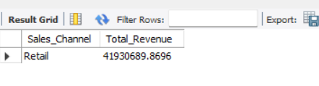
Business Insight
The RETAIL generated the highest revenue, suggesting it is the most effective distribution channel. Future marketing investments can focus on this channel to maximize profitability.

/*=========================================================
Business Question 7:
Which customer locations purchase the highest quantity
of dairy products?

Objective:
Identify the top-performing customer locations based on
purchase volume to support regional sales strategies.
=========================================================*/
SELECT Location,
SUM(Quantity) AS Purchase_Volume
FROM dairy
GROUP BY Location
ORDER BY Purchase_Volume DESC
LIMIT 5;
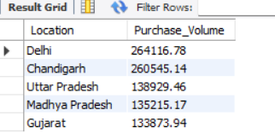
Business Insight
The analysis identified Delhi as the leading customer location by purchase volume. Expanding marketing campaigns and improving product availability in this region could increase overall sales.

/*=========================================================
Business Question 8:
What is the average selling price of each dairy product?

Objective:
Determine the average selling price of each product to
analyze pricing trends and product value.
=========================================================*/
SELECT Product_Name,
AVG(Price_per_Unit) AS Average_Selling_Price
FROM dairy
GROUP BY Product_Name;
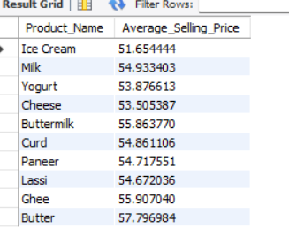
Business Insight
The average selling price analysis provides valuable insights into pricing consistency across products and can support future pricing strategies.

/*=========================================================
Business Question 9:
What is the difference between the listed price and the
actual selling price of each product?

Objective:
Compare listed prices with actual selling prices to
evaluate pricing strategies and discounts.
=========================================================*/
SELECT Product_Name,
Price_per_Unit AS Listed_Price,
Sales_Price_per_Unit AS Selling_Price,
(Sales_Price_per_Unit - Price_per_Unit) AS Price_Difference
FROM dairy;
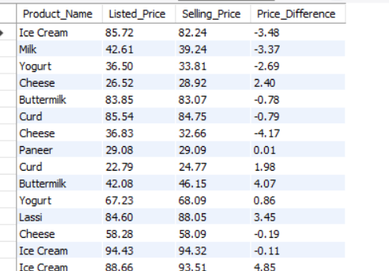
Business Insight
The comparison between listed and selling prices highlights pricing differences that may result from discounts or promotional offers. Monitoring these differences helps evaluate pricing effectiveness.

/*=========================================================
Business Question 10:
How many cows are maintained on average across each
farm size category?

Objective:
Analyze livestock distribution among different farm
sizes to understand production capacity.
=========================================================*/
SELECT Farm_Size,
AVG(Number_of_Cows) AS Average_Number_of_Cows
FROM dairy
GROUP BY Farm_Size;
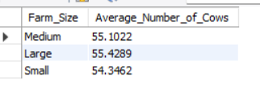
Business Insight
The analysis highlights the relationship between farm size and livestock capacity, providing valuable insights into production capabilities across different farm categories.

/*=========================================================
Business Question 11:
Which location has the largest total land area used
for dairy farming?

Objective:
Identify the location with the maximum land area to
understand regional farming capacity.
=========================================================*/
SELECT Location,
SUM(Total_Land_Area) AS Total_Land_Area
FROM dairy
GROUP BY Location
ORDER BY Total_Land_Area DESC
LIMIT 1;
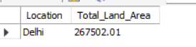

Business Insight
DELHI has the largest total land area, indicating greater production potential and higher farming capacity compared to other regions.

/*=========================================================
Business Question 12:
Which locations have the highest average production
quantity?

Objective:
Identify the most productive locations based on
average production volume.
=========================================================*/
SELECT Location,
AVG(Quantity) AS Average_Quantity
FROM dairy
GROUP BY Location
ORDER BY Average_Quantity DESC
LIMIT 3;
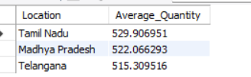
Business Insight
The top-performing production locations contribute significantly to overall dairy production and can serve as benchmarks for operational efficiency.

/*=========================================================
Business Question 13:
How much profit is generated by each dairy product?

Objective:
Calculate the estimated profit for each product to
evaluate product-level financial performance.
=========================================================*/
SELECT Product_Name,
(Price_per_Unit - Sales_Price_per_Unit) * Quantity AS Profit
FROM dairy;
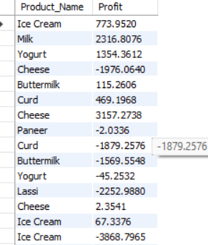

Business Insight
Profit analysis helps identify high-performing products that contribute the most to business profitability and supports better product portfolio decisions.

/*=========================================================
Business Question 14:
Which dairy brand generates the highest overall profit?

Objective:
Identify the most profitable brand by comparing total
profit across all brands.
=========================================================*/
SELECT Brand,
SUM((Price_per_Unit - Sales_Price_per_Unit) * Quantity) AS Total_Profit
FROM dairy
GROUP BY Brand
ORDER BY Total_Profit DESC
LIMIT 1;
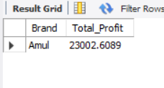
Business Insight
AMUL generated the highest overall profit, making it the strongest contributor to business profitability and a key focus for future growth strategies.

/*========================================================
Business Question 15:
How has the total revenue changed over the years?

Objective:
Analyze yearly revenue trends to evaluate business
growth and long-term financial performance.
=========================================================*/
SELECT YEAR(Orders_Date) AS Year,
SUM(Approx_Total_Revenue) AS Total_Revenue
FROM dairy
GROUP BY YEAR(Orders_Date)
ORDER BY Year;
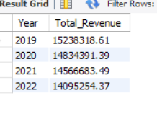
Business Insight
The yearly revenue trend reflects the company's financial performance over time. An increasing trend indicates business growth, while declining revenue may require strategic improvements.

/*=========================================================
Business Question 16:
Which dairy product achieved the highest sales in each year?

Objective:
Identify the best-selling product annually to understand
customer demand and product performance over time.
=========================================================*/
SELECT YEAR(Orders_Date) AS Year,
Product_Name,
SUM(Quantity) AS Total_Sold
FROM dairy
GROUP BY YEAR(Orders_Date), Product_Name
ORDER BY Year, Total_Sold DESC;
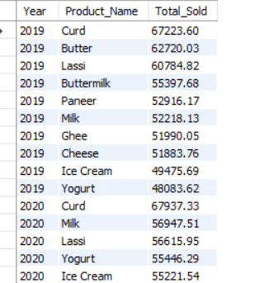
Business Insight
The best-selling products reflect changing customer preferences over time and can help guide future production planning and marketing strategies.

/*=========================================================
Business Question 17:
Which products require immediate restocking based on
their current inventory levels?

Objective:
Identify products with critically low stock to ensure
continuous product availability and prevent stockouts.
=========================================================*/
SELECT Product_Name,
Quantity_In_Stock
FROM dairy
WHERE Quantity_In_Stock < 50;
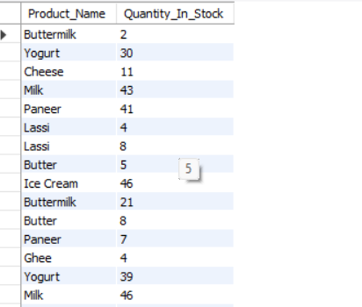
Business Insight
Products identified for immediate restocking should be prioritized to maintain uninterrupted product availability and improve customer satisfaction.

/*=========================================================
Business Question 18:
Are there any expired products that are still available
in inventory?

Objective:
Identify expired products that remain in stock to
support inventory quality control and compliance.
=========================================================*/
SELECT Product_Name,
Expiration_Date,
Quantity_In_Stock
FROM dairy
WHERE Expiration_Date < CURDATE()
AND Quantity_In_Stock > 0;
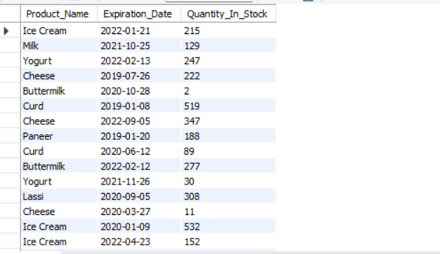
Business Insight
The presence of expired products in inventory highlights the need for stronger inventory monitoring and timely stock rotation to ensure product quality and reduce waste.

/*=========================================================
Business Question 19:
What is the average shelf life of products offered by
each dairy brand?

Objective:
Compare the average shelf life across brands to evaluate
product quality and storage characteristics.
=========================================================*/
SELECT Brand,
AVG(Shelf_Life) AS Average_Shelf_Life
FROM dairy
GROUP BY Brand;
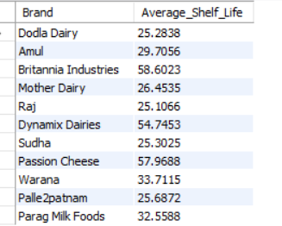
Business Insight
Comparing shelf life across brands helps evaluate product durability and supports better storage and inventory planning.

/*=========================================================
Business Question 20:
Which dairy product is most frequently purchased in
each customer location?

Objective:
Identify customer preferences across different locations
to support regional marketing and inventory planning.
=========================================================*/
SELECT Customer_Location,
Product_Name,
COUNT(*) AS Total_Orders
FROM dairy
GROUP BY Customer_Location, Product_Name
ORDER BY Customer_Location, Total_Orders DESC;
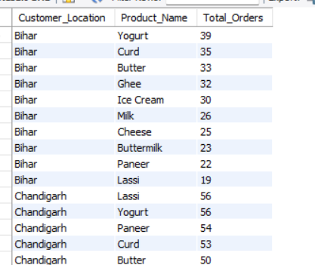
Business Insight
Customer preferences vary across different locations. Understanding regional purchasing patterns enables businesses to optimize inventory distribution and implement targeted marketing strategies.

6. Overall Key Findings
The SQL analysis provided valuable insights into the sales performance, inventory status, profitability, and operational efficiency of the dairy business. The major findings of the project are summarized below:
- Identified the total number of records available for analysis.
- Evaluated product-wise revenue to determine the highest revenue-generating products.
- Identified the best-performing brand based on total revenue.
- Analyzed monthly revenue trends to understand sales patterns over time.
- Detected products with low inventory levels requiring immediate attention.
- Calculated reorder quantities to support efficient inventory management.
- Determined the most profitable sales channel.
- Identified the top customer locations based on purchase volume.
- Compared listed prices with selling prices to evaluate pricing strategies.
- Analyzed product shelf life to support inventory planning.
- Evaluated production capacity based on farm size and land area.
- Measured product-level and brand-level profitability.
- Tracked yearly revenue trends to monitor business growth.
- Identified best-selling products across different years.
- Detected expired products that remained in inventory.
- Analyzed customer purchasing preferences across different locations.

7. Business Recommendations
Based on the findings obtained from the SQL analysis, the following recommendations can help improve business performance and operational efficiency:
- Maintain adequate inventory levels for high-demand products to prevent stock shortages.
- Prioritize restocking of products that fall below the minimum stock threshold.
- Increase promotional activities for high-performing products and brands to maximize revenue.
- Strengthen the most profitable sales channel by investing in marketing and customer engagement.
- Monitor product shelf life regularly to minimize product wastage and improve inventory turnover.
- Remove expired products from inventory promptly to maintain product quality and customer trust.
- Focus marketing campaigns on customer locations with the highest purchase volume.
- Review pricing strategies periodically to improve profitability while remaining competitive.
- Continuously monitor yearly sales trends to support better forecasting and business planning.
- Implement automated inventory monitoring systems to improve operational efficiency.

8. Skills Demonstrated

Technical Skills
- SQL (Structured Query Language)
- MySQL Workbench
- Database Creation and Management
- Data Import and Validation
- Data Aggregation and Analysis
- Date Functions
- Aggregate Functions
- Filtering and Sorting
- Grouping and Reporting

SQL Concepts Applied
- CREATE DATABASE
- CREATE TABLE
- SELECT
- WHERE
- GROUP BY
- ORDER BY
- LIMIT
- Aggregate Functions (SUM, AVG, COUNT)
- Date Functions (YEAR, MONTH, DATEDIFF)
- Arithmetic Expressions
- Data Filtering

Analytical Skills
- Revenue Analysis
- Profitability Analysis
- Inventory Management
- Sales Trend Analysis
- Customer Behavior Analysis
- Business Reporting
- Decision Support
- Business Insight Generation

9. Conclusion
The Dairy Management System SQL Analysis project demonstrates the practical application of SQL in solving real-world business problems. By performing data exploration, sales analysis, inventory monitoring, profitability evaluation, and customer behavior analysis, meaningful business insights were extracted from the dataset.
The project highlights the ability to design a relational database, write optimized SQL queries, analyze business performance, and transform raw data into actionable insights. It also demonstrates strong analytical thinking and problem-solving skills that are essential for Data Analyst and Business Intelligence roles.
Overall, this project showcases proficiency in SQL, database management, and business analytics while emphasizing the importance of data-driven decision-making in improving organizational performance.

